

GREEK REPUBLIC April 2012
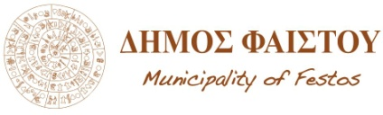

25th March 1
Mires, Heraklion 70400 Crete

PARTICIPATION FORM- MATALA FESTIVAL 2012

PARTICIPATION FORM

OFFICIAL MAIL:

REPRESENTATIVE:

ADDRESS/ZIP.:

PHONE/MOBILE/FAX/ MAIL:

TAX INFO (IF APPLICABLE)

TYPE OF PARTICIPATION:

DESCRIPTION AND CHARACTERISTICS (eg. Members, instruments, technical riders, duration, fee, special requests etc)

REMARKS/SPECIAL AGREEMENTS (please attach here or in email, logo, links, website, photos, facebook etc):

The representative of event, signature

I agree to represent the band or company and I will be the person responsible for all arrangements and negotiations with the Festival committee.

